Experiment -2

NAME: J.Harsan ROLL NO:240701179
Design a UI where users recall visual elements (e.g., icons or text chunks). Evaluate the effect of chunking on user memory.
FRAME 1:
INSTRUCTION PAGE:

What is chunking?
- Chunking is the process of breaking large or complex information into smaller, meaningful groups.
- It helps users understand, remember, and use information more effectively.
- Chunking reduces mental effort by organizing information logically.

Why is chunking important?
- The human brain can process only a limited amount of information at a time.
- Chunking helps by:
  - Reducing cognitive load
  - Improving understanding
  - Enhancing memory retention
  - Making user interfaces easier to use

Why is chunking used?
- Reduces cognitive overload during information processing
- Improves memory and learning efficiency
- Makes complex data easier to handle
- Supports problem-solving and data processing

Types of chunking
- Fixed-size chunking
  - Information is divided into equal-sized blocks.
  - Example: Splitting a file into 1 KB blocks.
- Variable-size chunking
  - Chunks are created based on meaning or patterns.
  - Example: Splitting text into sentences or paragraphs.

Design and visual analysis
- Aesthetic
  - Uses a dark mode theme with a deep navy background.
  - Vibrant accent colors such as blue, green, and purple enhance visual appeal.
- Typography
  - Clean, sans-serif fonts are used for high readability.
  - Suitable for a cognitive testing environment.
- Iconography
  - Simple and stylized icons are used to represent different phases of the experiment.
  - Icons help users quickly understand the interface flow.

Simplicity and clarity
- Instructions are written using short and direct sentences.
- Unnecessary complexity is avoided.
- Active voice makes the interface more engaging and action-oriented.

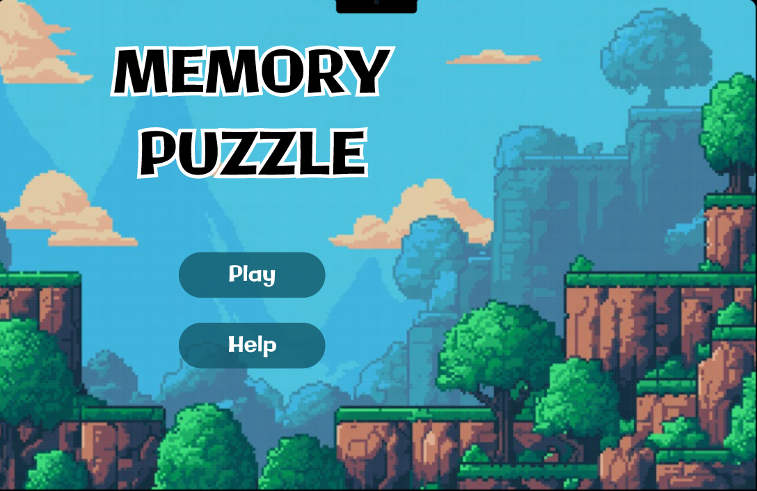
FRAME 2:
CHUNKING PHASE:

Analysis of the Memory Recall Task - Chunking Phase Screen
This screen represents the Chunking Phase of a Memory Recall Task, where users observe and memorize different icons within a limited time. Below is a breakdown of its key components:

Purpose of the screen
- Represents the visual memory encoding phase of the experiment.
- Users observe and mentally group icons before recall.
- Applies the chunking principle to improve memory retention.

Chunking method
- Items are grouped into meaningful, color-coded categories:
  - Nature: Sun and lightning icons
  - Shapes: Triangle, heart, star, square, and circle
  - Objects: Camera, musical note, and tablet/book
  - Communication: Envelope and telephone icons

How the chunking phase works
- Users scan the grid to identify patterns and related items.
- A countdown timer limits observation time.
- After the timer ends, users move to the recall phase.

Cognitive and UX benefits of chunking
- Enhances short-term memory through grouped recall.
- Reduces cognitive overload by organizing information.
- Improves pattern recognition and recall accuracy.
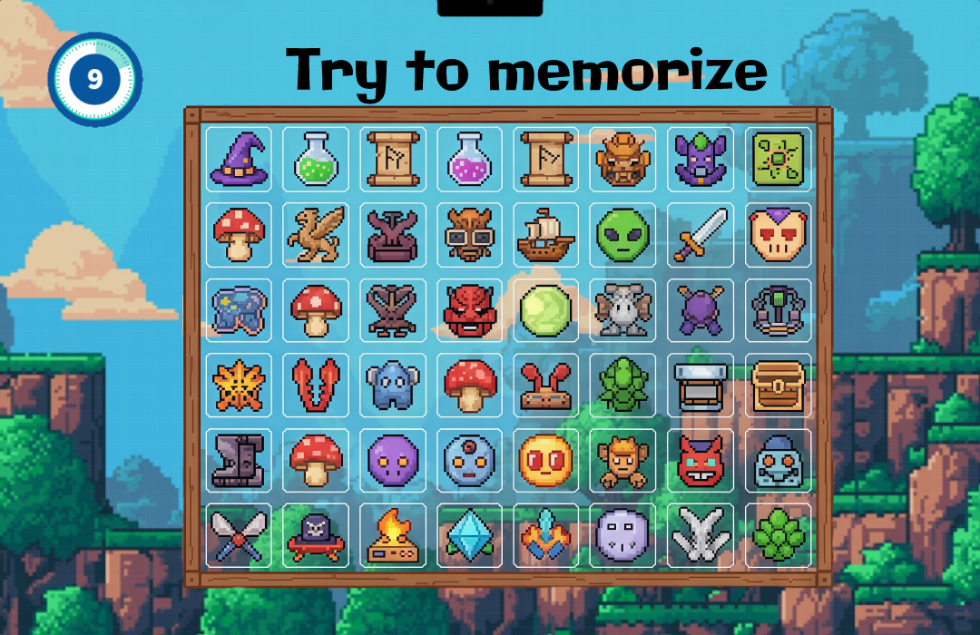
FRAME 3:
RECALL PHASE:

Analysis of the Memory Recall Task - Selection Phase
This image displays the Recall Phase results of a cognitive experiment, specifically focusing on how grouping information affects memory accuracy. This particular test was conducted under the "Grouped by Category" condition.

Purpose of the screen
- Represents the memory retrieval stage of the experiment.
- Users select the icons they remember seeing in the chunking phase.
- Evaluates short-term memory retention and the effectiveness of chunking.

Key elements and UI components

Top-level metadata and navigation
- Header label “Recall Phase” clearly indicates the current stage.
- Instructional text guides users to select remembered icons.
- The layout keeps focus on the selection task without distractions.

Primary metric scorecards
- Uses a traffic-light color system:
  - Green: Correct selections
  - Red: Incorrect selections
  - Yellow/Orange: Missed selections

Results grid
- Displays a structured 4×54 \times 54×5 grid of interactive tiles.
- Each tile shows a checkmark or cross indicating correctness.
- Color-coded borders indicate:
  - Green: Correctly identified icons
  - Red: False positives
  - Dimmed: Unselected or incorrect items

Icon selection grid
- Displays a structured grid containing:
  - Icons shown in the study phase
  - Additional distractor icons
- All icons are presented uniformly without indicating correctness.
- Users select icons based purely on memory recall.

Design Language & UX
- Dark Mode Background: Uses a deep charcoal/navy to reduce eye strain and make the colored borders pop.
- High-Affordance Feedback: The use of both color (red/green) and symbols (check/X) ensures the interface is accessible for users with color vision deficiencies.
- Symmetry: The grid is perfectly aligned, allowing the user to scan their "mistakes" vs. "successes" systematically.

How the selection phase works
- Users recall icons seen during the chunking phase.
- They select the icons they remember from the grid.
- Distractor icons test the accuracy of recall.
- Clicking the “Submit” button finalizes the user’s responses.

Cognitive and UX benefits
- Tests genuine memory recall without visual hints.
- Encourages careful decision-making based on memory.
- Simple layout minimizes cognitive load.
- Gamified interaction keeps users engaged.

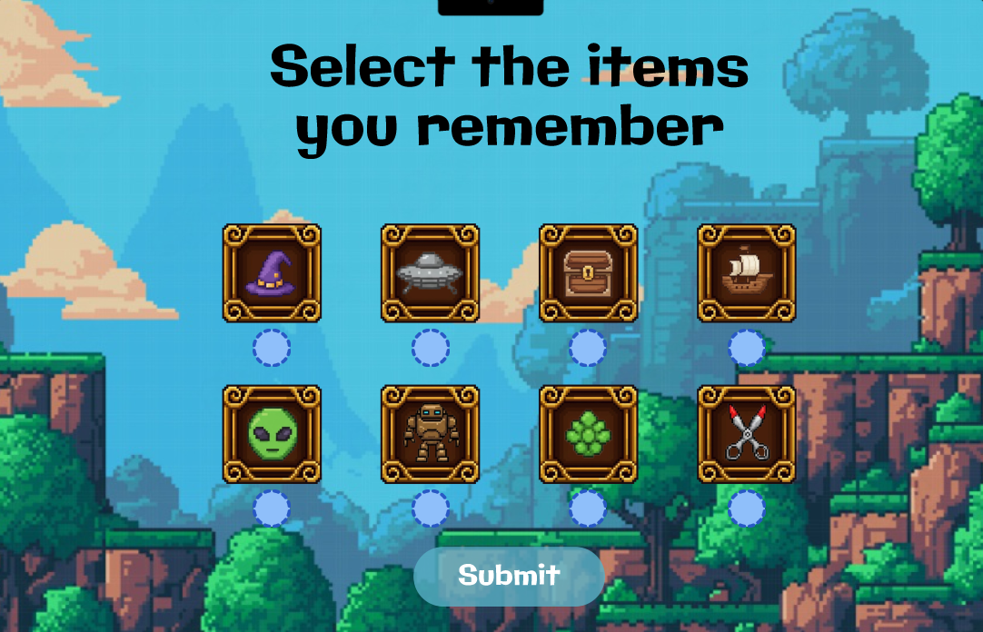
FRAME 4:
RESULT PAGE:

Analysis of the Memory Recall Task - Score & Feedback Screen
This screen represents the Score & Feedback Phase of the Memory Recall Task, where users receive their performance evaluation based on the selections made in the previous Recall Phase.

Purpose of the screen
- Displays the overall memory performance of the user.
- Shows how many items were correctly recalled out of the total.
- Allows users to retry the test or proceed further.

Performance breakdown
- Shows the total number of correct answers.
- Displays accuracy as a fraction or percentage (e.g., 3/8).
- Does not visually mark individual icons as right or wrong.
- Focuses on overall performance rather than detailed error analysis.

Cognitive and UX benefits
- Score-based feedback provides clear performance insight.
- Avoids confusion by not highlighting individual mistakes.
- Encourages users to improve by retaking the test.
- Clean and minimal design keeps feedback easy to understand.
- Supports fair comparison between chunked and non-chunked conditions.
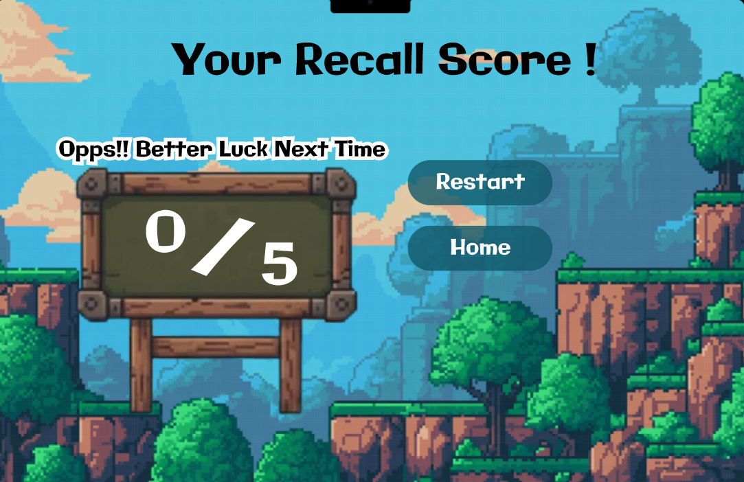

PROTOTYPE LINK:
https://www.figma.com/proto/OsoB83fDwJPlodU4RM7SPE/UID-EX-2?node-id=18-255&p=f&t=i0jLAcdkFDQn2LzN-1&scaling=scale-down&content-scaling=fixed&page-id=0%3A1&starting-point-node-id=1%3A2

